PROJECT TITLE

A course project report submitted in partial fulfilment of the requirement
of
DEVOPS AND FULLSTACK
by

B.KARTHIK (210351323)
B.KARTHIK (210351323)
B.KARTHIK (210351323)
B.KARTHIK (210351323)

Under the guidance of
Dr. N.VENKATESH
Asst. Professor, Department of CS & AI


SR University, Warangal
APRIL-2026
ABSTRACT
The main aim of this project presents the implementation of a cost-effective Home Automation System with remote control. This framework is intended to help and give help to satisfy the needs of the elderly and the handicapped at houses. Additionally, the idea of a home automation system will improve the normal living status of houses. This system is designed to control electrical devices throughout the house with ease of installing it, ease of use, and cost-effective design and implementation. Our main idea is to develop a system to provide people a living environment with security, comfort, environmental protection, and intelligence. We introduced a technology which will not only save our money and time but will prove to be beneficial and effective for the economy.

CONTENTS

ABSTRACT ii

Chapter No. Title Page No.

1 INTRODUCTION 01
1.1 About the project 01
1.2 Objectives 02

2 LITERATURE REVIEW
2.1 Overview 03
2.2 Related Studies and Existing Solutions 05
2.3 Tools and Technologies Used 07

3. METHODOLOGY
3.1 Data Collection and Description 08
3.2 Data Preprocessing and Cleaning 10
3.3 Analytical and Visualization Techniques 12

4 RESULTS AND DISCUSSION
4.1 Data Analysis and Key Findings 14
4.2 Visualization and Interpretation of Results 16
4.3 Insights and Discussion 18

5 CONCLUSION AND FUTURE WORK
5.1 Summary of Findings 19
5.2 Conclusions Drawn 20
5.3 Recommendations and Future Scope 20

CHAPTER 2: LITERATURE REVIEW
DevOps and Full-Stack Application Development
DevOps has emerged as a transformative approach in modern software engineering by bridging the traditional gap between development and operations teams. The concept gained prominence around 2009 and emphasizes collaboration, automation, continuous integration, and continuous deployment throughout the software development lifecycle. Researchers such as Humble and Farley (2010) highlighted that continuous delivery practices significantly reduce deployment risks while improving software reliability and release frequency. DevOps integrates development, testing, deployment, monitoring, and feedback mechanisms into a continuous and automated pipeline, thereby enhancing efficiency and reducing time-to-market.
Continuous Integration and Continuous Deployment (CI/CD) are core components of DevOps practices. CI/CD pipelines automate code building, testing, and deployment processes, enabling rapid and reliable software releases. Tools such as Jenkins, GitHub Actions, and GitLab CI/CD are widely adopted for implementing automated workflows. Literature indicates that CI practices help detect defects early, minimize integration conflicts, and enhance collaborative development. Automated deployment further ensures consistency across staging and production environments.
Containerization has significantly influenced DevOps implementation by enabling consistent application environments. Docker introduced lightweight containers that package applications along with their dependencies, ensuring portability across different systems. This approach reduces configuration mismatches and improves scalability. For orchestration and large-scale container management, Kubernetes provides automated scaling, load balancing, and self-healing capabilities. Studies suggest that container-based deployment improves resource utilization and simplifies microservices architecture implementation.
Version control systems form the backbone of collaborative software development in both DevOps and full-stack environments. Git enables distributed source code management and supports branching, merging, and pull request workflows. Research demonstrates that structured version control strategies enhance maintainability, reduce development conflicts, and improve overall software quality.
Full-stack development integrates both frontend and backend technologies to build complete web applications. On the frontend, frameworks such as React and Angular facilitate dynamic user interfaces and component-based architectures. On the backend, technologies like Node.js and Express.js enable scalable server-side development and RESTful API integration. Literature suggests that full-stack frameworks enhance development productivity, modular design, and seamless client–server communication. The integration of frontend and backend technologies within a unified ecosystem accelerates application delivery and supports agile methodologies.
Database integration is another critical aspect of full-stack systems. Relational databases such as MySQL provide structured data management and strong consistency, while NoSQL databases such as MongoDB offer flexible schemas and horizontal scalability. Comparative studies highlight that NoSQL databases are often preferred in JavaScript-based full-stack ecosystems due to their schema flexibility and JSON-like document storage format.
Infrastructure as Code (IaC) further strengthens DevOps maturity by automating infrastructure provisioning and configuration management. Tools like Terraform and Ansible allow developers to define infrastructure through code, improving reproducibility and reducing manual errors. Research indicates that IaC enhances deployment consistency and supports cloud-native application development.
Monitoring and observability are essential for maintaining reliability in production systems. Tools such as Prometheus and Grafana enable real-time performance tracking, log aggregation, and alert-based incident management. Literature emphasizes that proactive monitoring reduces downtime and improves system resilience.
Overall, existing studies demonstrate that the integration of DevOps practices with full-stack development significantly enhances software quality, deployment speed, scalability, and collaboration efficiency. The convergence of automation, containerization, CI/CD pipelines, infrastructure management, and monitoring represents a paradigm shift from traditional development models toward agile, cloud-native, and continuously evolving software systems.

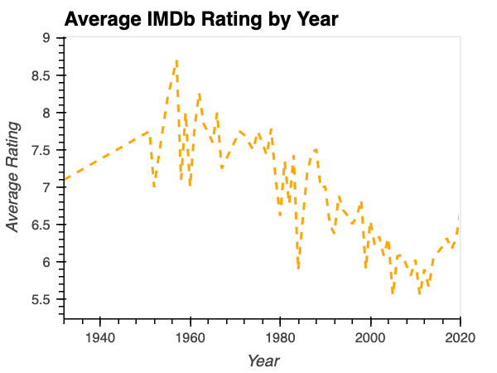
Figure 1.1 : Line Chart illustrating trends over time

Table 1.1 Category
Interest/ level | Low | Medium | High
Low | 1 | 0 | 0
Medium | 0 | 1 | 0
High | 0 | 0 | 1

